Hi Team her is the information of how we integrate our Student Learning Outcomes
It is all input into the software online. Here is the information about WEAVEonline:

This isn’t an ad as it takes a great deal of work to get setup for a department, but I like the fact you can set areas in your program where additional funding would improve your work. This is blanket software for the entire University • Every Department

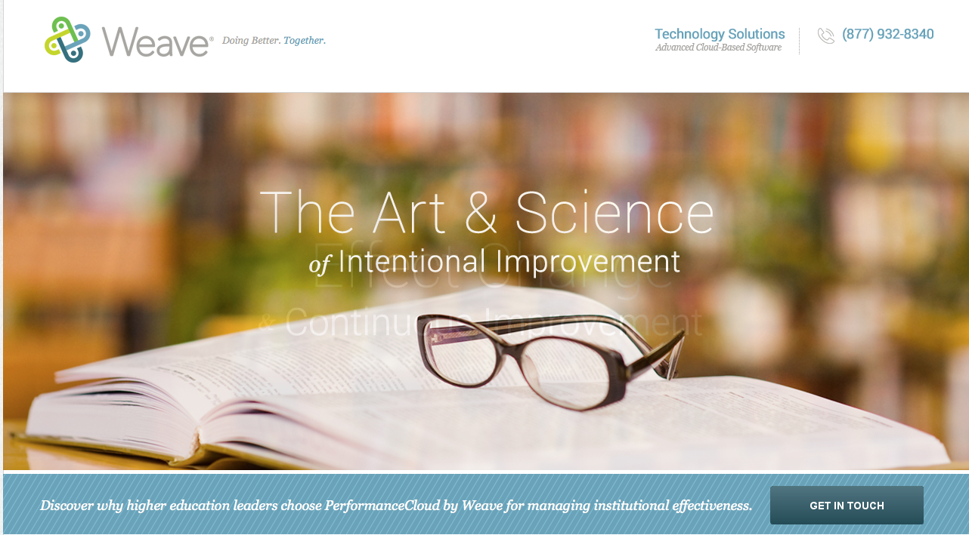

http://www.weaveengaged.com

Accreditation

Accreditors expect their member institutions to be committed to quality and engaged in continuous improvement, as well as to demonstrate how well they meet their stated missions. WEAVEonline member institutions are easily able to establish and manage these quality assurance and quality enhancement processes. And because the application literally weaves assessment, planning, accreditation, and budgeting, all within the context of your institution’s priorities, you can demonstrate your commitment to excellence to accreditors and other stakeholders through an integrated approach of your continuous improvement processes.

Click here to see how our consulting group can augment your accreditation efforts on campus.

Click here to view how to learn more about our world-class technology!

WEAVEonline software can help institutions of higher education manage the following accreditation-related processes:

Organize the Work
- Load regional and many disciplinary/programmatic standards from the Standards Shelf
- Provide built-in continuous improvement process forms to demonstrate institutional effectiveness
- Integrate
- Differentiate student learning outcomes from other mission-driven outcomes and objectives
- Associate outcomes and objectives with goals, general education, institutional priorities, standards, and strategic plans

Close the Loop
- Summarize where targets are met, partially met, and not met
- Develop action plans in response to assessment results or to enhance quality
- Ask analysis questions to address topics such as using results for improvement

Document
- Log implementation steps to document progress on action plans
- Provide supporting evidence for each step of the process via a Document Repository
- Compile assessment-specific and standards-specific reports for full documentation

Beyond the Software…
- Access WEAVE’s webinar archive for guidance during the accreditation preparation process
- Receive consulting from experienced educators and evaluators (separate fee)

